InComm

TIBCO API Exchange Gateway

**User Guide**

Version <1.0>



|  |  |  |  |
| --- | --- | --- | --- |
|  | **Prepared By / Last Updated By** | **Reviewed By** | **Approved By** |
| **Name** | Dwiz Kumar |  |  |
| **Role** |  |  |  |
| **Signature** |  |  |  |
| **Date** | 2 June 2015 |  |  |

Table of Contents

1.0 Document Overview 3

1.1 Document Purpose 3

1.2 References 3

1.3 Definitions, Acronyms and Abbreviations 3

2.0 TIBCO APIX Gateway Configuration 3

2.1 Gateway 3

3.0 Appendix A – Change Log 9

# Document Overview

## Document Purpose

This document is intended to provide guideline on setting up TIBCO API Gateway. As a pre-requisite,

It is required to have TIBCO API Gateway installed and configured successfully as per the product installation document.

## References

Use this section to fill-in reference documents used

|  |  |
| --- | --- |
| ***Document#*** | ***Document Title*** |
|  |  |
|  |  |

## Definitions, Acronyms and Abbreviations

Use this section to fill-in definitions of acronyms & abbreviations used in this document

|  |  |
| --- | --- |
| ***Term, Acronym*** | ***Definition*** |
|  |  |
|  |  |

# TIBCO APIX Gateway Configuration

## Gateway

1. Start ConfigUI by:

<ASG_HOME/bin>asg-configui

(Eg : /opt/tibco/asg/2.1/bin)

1. Run ConfigUI Portal at :

http://<hostname>:<configUIport>/ConfigUI/

(<http://localhost:9200> /ConfigUI/).

1. Login to the portal with appropriate creds (admin,admin)
2. Create a duplicate project from the default project:

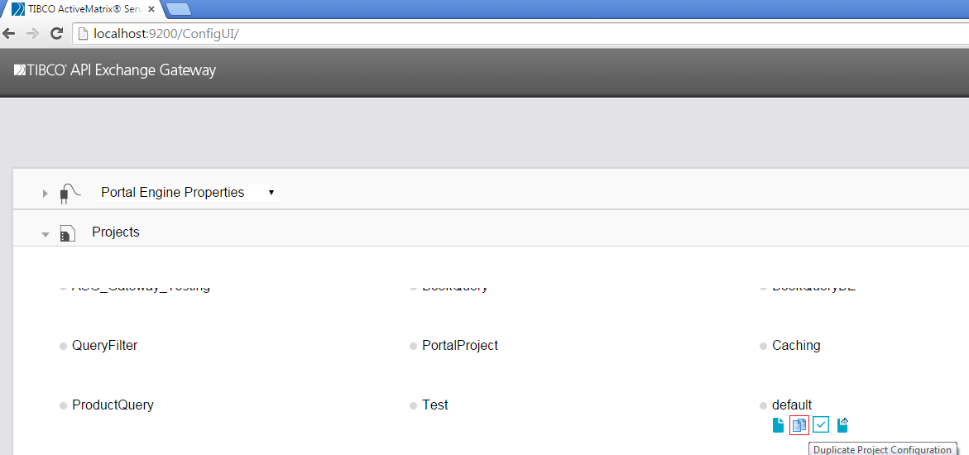

1. Rename the project to appropriate project name:

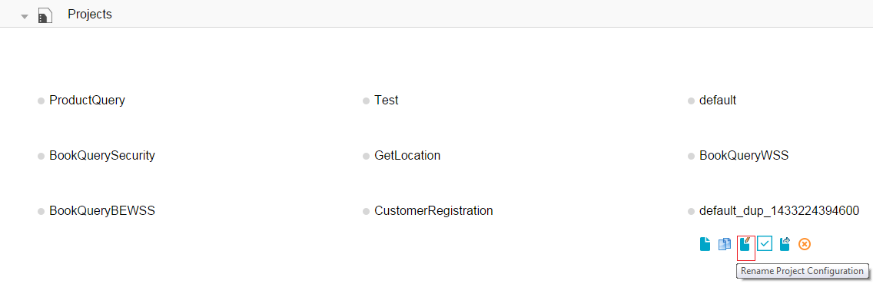

1. Click on the project name to open it.
2. Click on partner tab.
3. Select the partners tab and define a new partner by clicking add property icon.

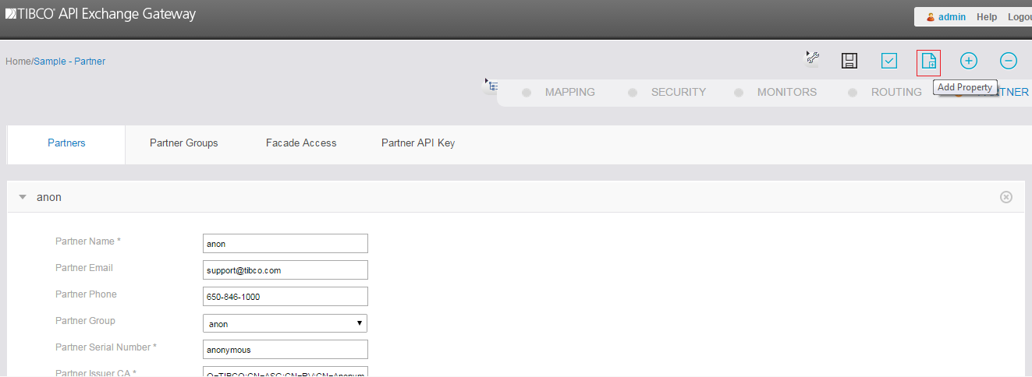

1. Save the new partner configuration.

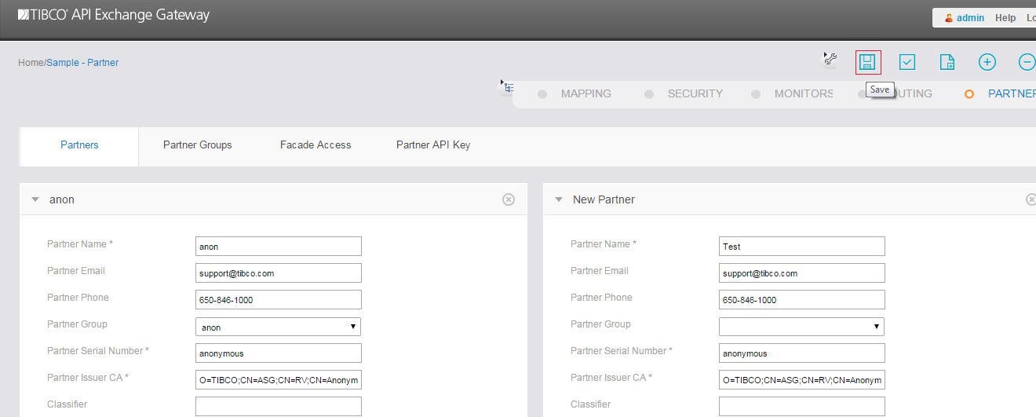

1. Define the Partner Group if required and add this partner to that group (optional).
2. Define Partner API Key for authentication and save it.

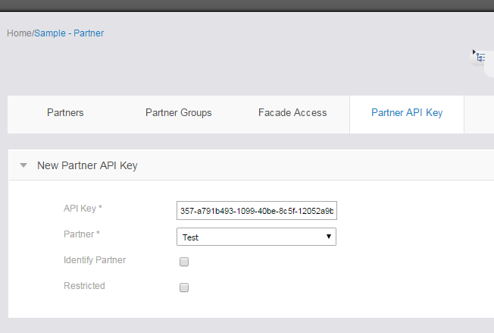

1. Select the Routing tab and click on the façade operation.
2. Define façade operation by configuring operation name, operation URI, operation method etc. and save the configuration.

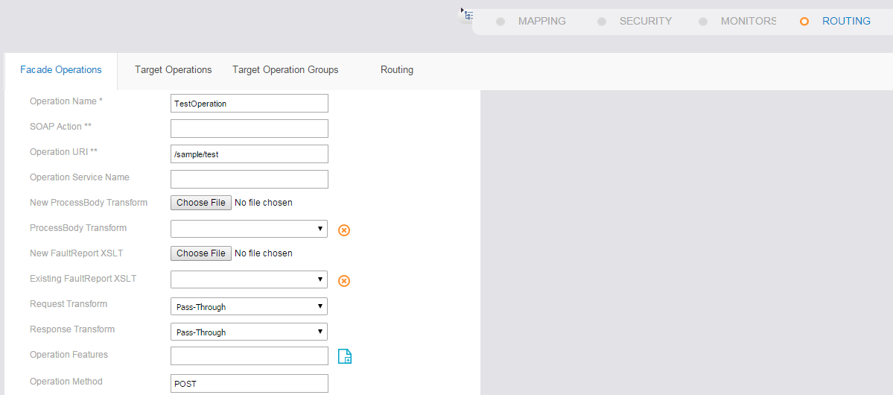

1. Define target operation by configuring Target operation name, Type, URI, Host, Port, Header to forward (if header or query string is present in the request), Method etc. and save the configuration.

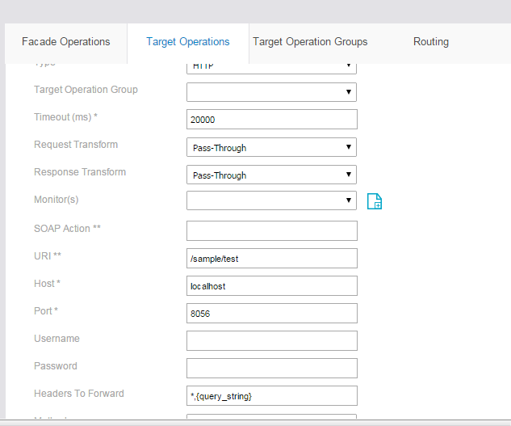

1. Define target operation group if required for LoadBalancing.
2. In routing add the façade and target operation defines above and save the configuration.

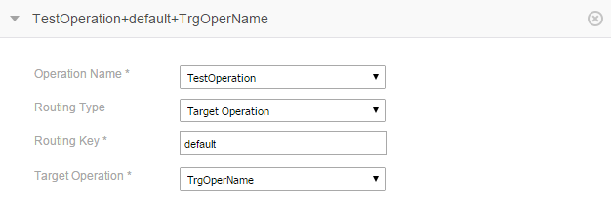

1. Go to the partner tab again and define Façade access for façade operation defined above with the generated partner API key and save the configuration.

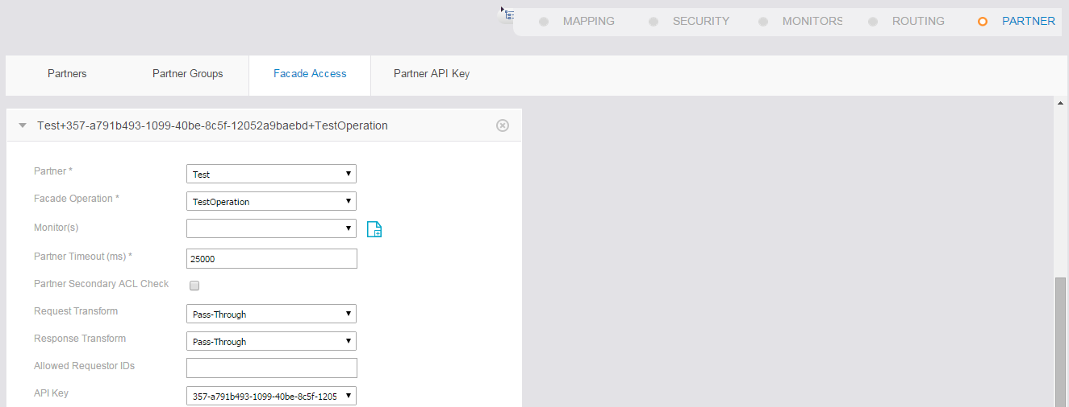

1. Click on Home (present in top left corner).
2. Publish the updated configuration, if asg engine has been already running. So, that the configuration changes should reflect.

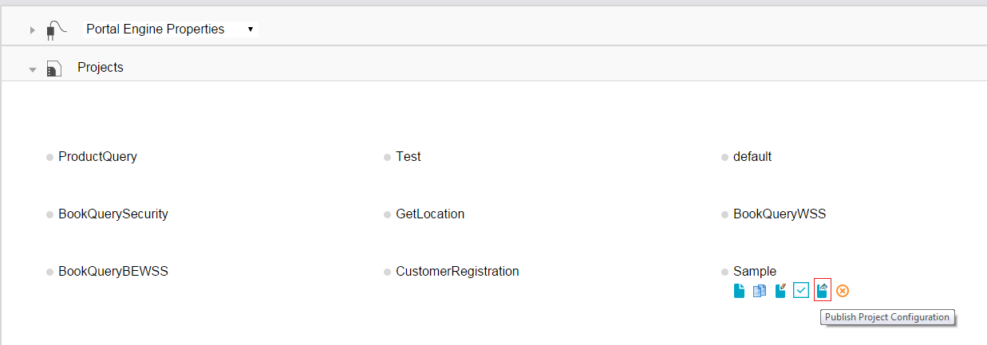

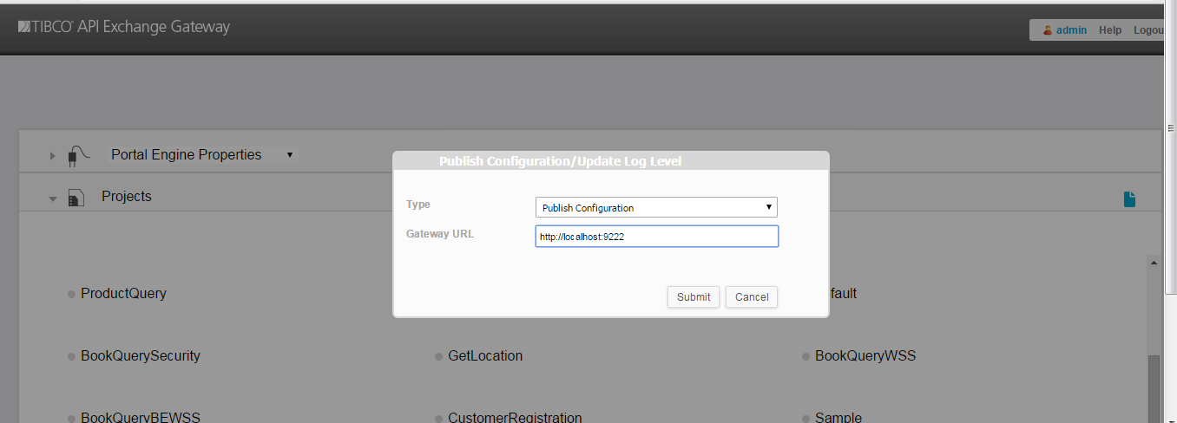

1. Click on submit.

# Appendix A – Change Log

|  |  |  |  |  |
| --- | --- | --- | --- | --- |
| ***Version Number*** | ***Changes Made*** | | | |
| Vx.y | Initial baseline created on xx-Feb-2014 | | | |
| Vx.y |  | | | |
| **Section No.** | **Changed By** | **Effective Date** | **Changes Effected** |
|  |  |  |  |
| Vx.y |  | | | |
| **Section No.** | **Changed By** | **Effective Date** | **Changes Effected** |
|  |  |  |  |
| Vx.y |  | | | |
| **Section No.** | **Changed By** | **Effective Date** | **Changes Effected** |
|  |  |  |  |